ASSESSMENT IDEAS
Absorption by atmospheric gases of incoming and outgoing radiation

Goals:
- Estimate the absorption by Earth’s atmosphere of both incoming and outgoing radiation
- Contrast atmospheric constituents based on their absorption spectra
- Identify greenhouse and non-greenhouse gases based on their absorption spectra
- Estimate Earth’s surface temperature from satellite data

Some of the following questions could be administered with clickers in the class following the activity:

- Of the following, which atmospheric gas absorbs the MOST incoming solar radiation?
  - N₂
  - H₂O
  - CO₂
  - O₃
  - CH₄
- Of the following, which atmospheric gas absorbs the MOST outgoing radiation emitted by Earth’s surface?
  - N₂
  - H₂O
  - CO₂
  - O₃
  - CH₄
- Explain how the greenhouse effect works (open-ended. Would be useful to create a rubric for this question)
- What features differentiate greenhouse gases from other gases in the atmosphere?
Answer: GHG absorb IR at some wavelengths, and mostly transmit visible light; non-greenhouse gases are transparent to both visible and infrared light.
- Idea for a hypothetical scenario: Give an emissions spectrum for a planet at some temperature. Give absorption spectra of different atmospheric gases. Ask which would be greenhouse gases in this scenario. The greenhouse gases will be transparent to the peak wavelength of an external source of radiation. For Earth, greenhouse gases are transparent to visible light. Greenhouse gases will also absorb radiation for wavelengths at or near the peak of emission of the planet itself. For example, a question could be designed for a relatively cold planet that emits mostly in the microwave or even radio wave region. Candidate gases would have to be transparent in visible but absorb some wavelengths in the microwave or even radio wave region.

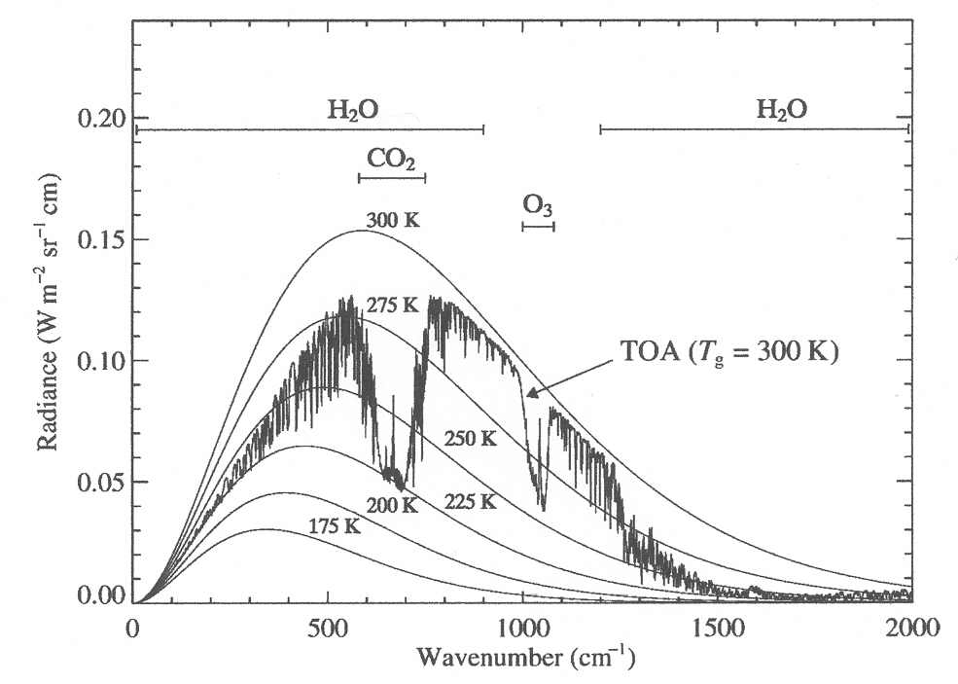

Figure for Question #6 below: Measured upwelling infrared radiance at 60 km for a clear sky, mid latitude, summer atmosphere (TOA = Top of Atmosphere) (wavelength in microns = (10,000/wavenumber in cm^-1), CO2 notch <=> 15 micron, O3 notch <=> 9.4 micron)
(Adapted from the book, "Radiation in the Atmosphere, A Course in Theoretical Meterology” by Zdunkowski, Trautmann, and Bott, 2007 Cambridge University Press)

- Use a figure similar to the one above (Note that the activity uses wavelength, and this figure uses wavenumber. You might not want to switch back and forth, or, if you do, be sure students are familiar with both units). Ask students to explain why the radiometer measurements from the top of the atmosphere looking down toward Earth do not always match the spectrum of Earth’s known surface temperature (about 288K). Ask them to explain why sections of the radiation curve match an object whose temperature is only 200K.
- Which of the following best describes how the greenhouse effect works?
- Greenhouse gases absorb incoming solar energy
- Greenhouse gases reflect incoming solar energy
- Greenhouse gases absorb solar energy reflected from Earth
- Greenhouse gases absorb energy radiated by Earth
- Greenhouse gases reflect energy radiated by Earth
(Note: This question has been validated with student interviews at UBC.)
- Idea for an assessment question: Get a satellite spectrum from looking down at a desert or at an ice sheet. Plot the spectrum with an assortment of blackbody curves. Ask the students to tell the temperature of the surface based on the spectrum (Answer: They will need to look at the wavelength range of the atmospheric window and match the spectrum to the blackbody curves, perhaps interpolating between them.)
(Credit: Phil Austin)
- The diagram below shows Earth’s radiation budget. Which arrow represents radiation at wavelengths between about 10 and 12 microns?
Answer: the one labeled “Atmospheric Window”
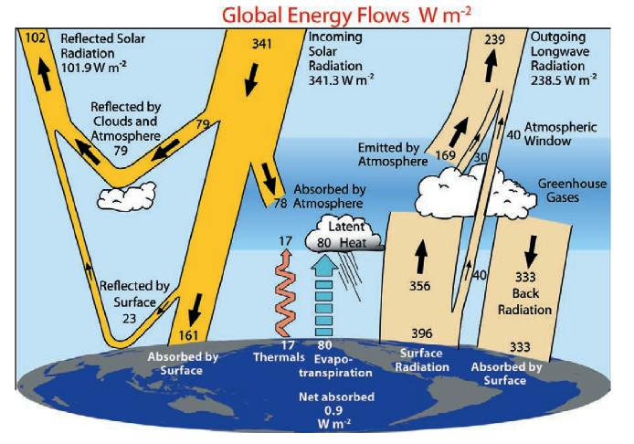
- If you wanted to measure Earth’s surface temperature with a satellite at the top of Earth’s atmosphere, and you could measure the radiation traveling by one of the pathways illustrated in the diagram above, which pathway would you choose?
Answer: the one labeled “Atmospheric Window”

The following questions are related to this activity, but some parts may require additional student work to get to the level expected:

The figure below shows the spectrum of solar radiation measured at both the top of the atmosphere (in yellow) and at Earth’s surface looking up toward the sun (in red).
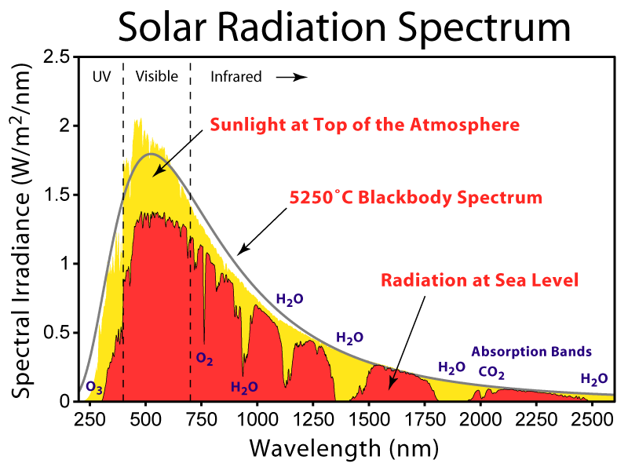
I

Figure adapted from and Image created by Robert A. Rohde / Global Warming Art

1. Explain the predominant reason why solar radiation measured at the top of the atmosphere and at sea level are different for the infrared portion of the spectrum. Be sure to explain the observed dips in spectral irradiance (the intensity of light) such as the one at location “I.”

2. Explain the predominant reason why solar radiation measured at the top of the atmosphere and at sea level are different for the visible portion of the spectrum.

3. Explain the predominant reason why solar radiation measured at the top of the atmosphere and at sea level are different for the ultraviolet (“UV”) portion of the spectrum.

Overarching Goal: EXPLAIN how the greenhouse effect works based on properties of atmospheric constituents and budget balancing.

A correct response would include words along the lines of: "Surface and atmospheric budgets are close to balanced. The surface has two energy sources (1) Sun, (2) Longwave IR from the atmosphere. The Earth's surface has to get rid of same amount of energy as it absorbs. S-B says it has to be a certain temperature to emit this much. [Same principle for balancing budget in atm]. If the amount of greenhouse gases in atmosphere changes, the atmosphere will absorb more/less energy, thus changing the amount the atmosphere has to emit, which changes the amount the Earth's surface absorbs from atmosphere, which in turn changes the amount Earth has to emit, and thus the Earth's temperature changes."

